April 26 – Bug Docu/Not working functionalities

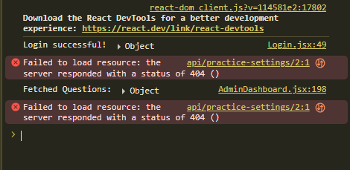
Error Occurred in proceeding to choices when Question has Image

ERROR TEXT:
react-dom client.js?v=114581e2:17802
Download the React DevTools for a better development experience: https://react.dev/link/react-devtools
Login successful! ▶ Object Login.jsx:49
❌ Failed to load resource: the server responded with a status of 404 ()
api/practice-settings/2:1

Fetched Questions: ▶ Object AdminDashboard.jsx:198

❌ Failed to load resource: the server responded with a status of 404 ()
api/practice-settings/2:1

Cannot view image on choices after adding
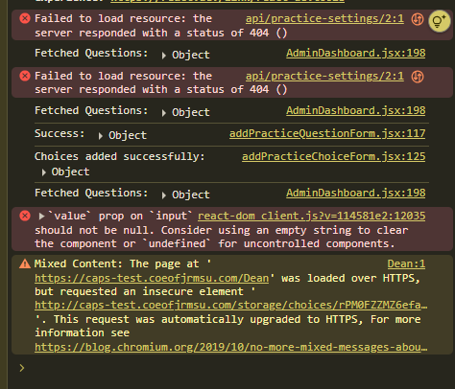

ERROR TEXT:
react-dom client.js?v=114581e2:17802
Download the React DevTools for a better development experience: https://react.dev/link/react-devtools

❌ Failed to load resource: the server responded with a status of 404 ()
api/practice-settings/2:1

Fetched Questions: ▶ Object AdminDashboard.jsx:198

❌ Failed to load resource: the server responded with a status of 404 ()
api/practice-settings/2:1

Fetched Questions: ▶ Object AdminDashboard.jsx:198
Success: ▶ Object addPracticeQuestionForm.jsx:117
Choices added successfully: ▶ Object addPracticeChoiceForm.jsx:125
Fetched Questions: ▶ Object AdminDashboard.jsx:198

❌ `value` prop on `input` react-dom client.js?v=114581e2:12035
should not be null. Consider using an empty string to clear the component or `undefined` for uncontrolled components.

⚠️ Mixed Content: The page at 'https://caps-test.coeofjrmsu.com/Dean' was loaded over HTTPS, but requested an insecure element 'http://caps-test.coeofjrmsu.com/storage/choices/rPM0FZZMZ6efa...'.
This request was automatically upgraded to HTTPS. For more information see https://blog.chromium.org/2019/10/no-more-mixed-messages-about-https.html

